**CMPE 297 – Special Topics in Software Engineering**

**FALL 2017**



**iOS Application Development**

**Assignment 5 - iOS Step Count Assignment**

**Submitted by- Submitted to-**

Anvit Saxena Prof. Chandrashekhar

SJSU ID: 010953436

Screenshot 1: The below screen shot shows the logs when application is run and it updates the steps and data.

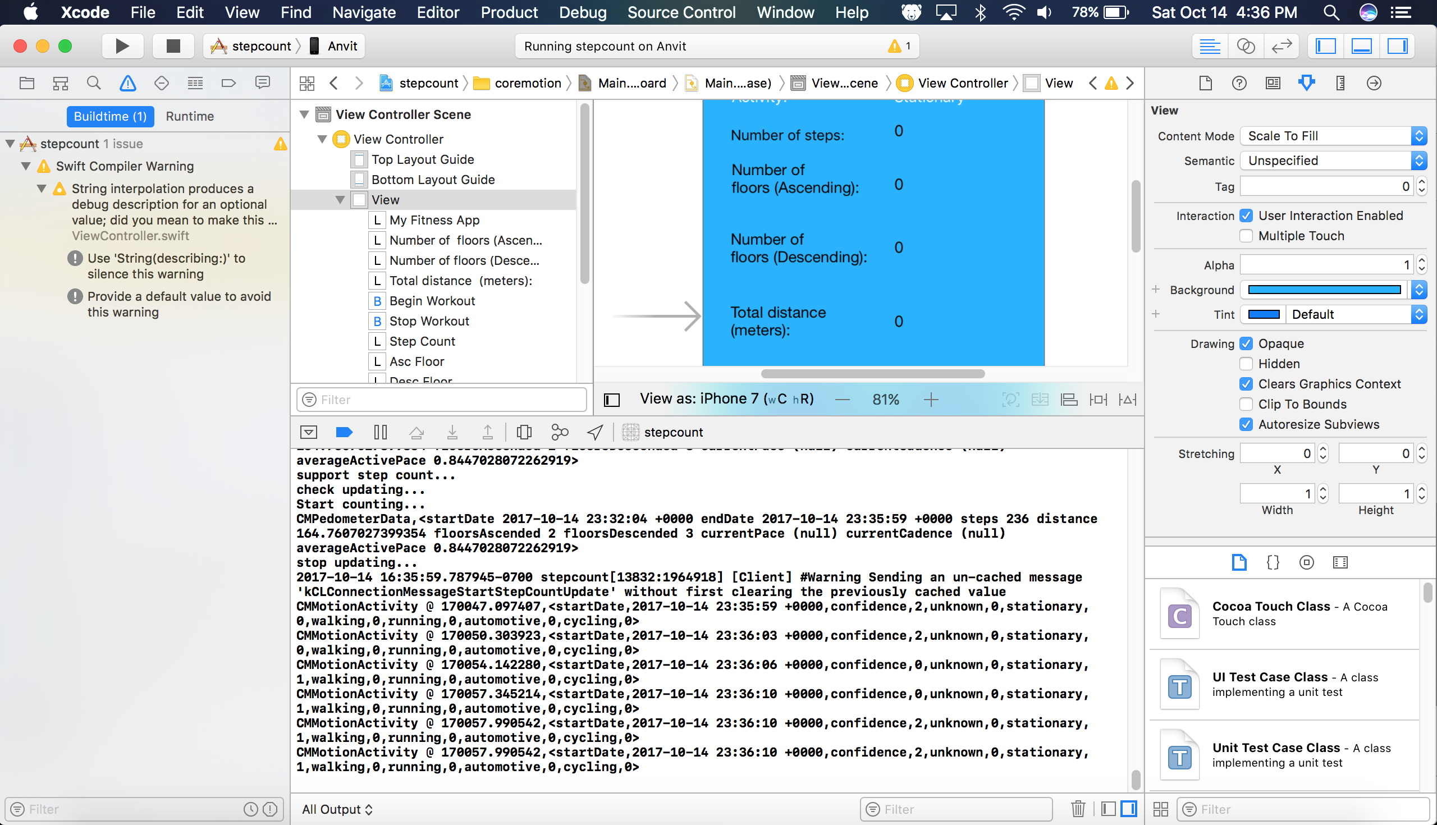

Screenshot 2: This shows the the developer account I used to run this application on phone.

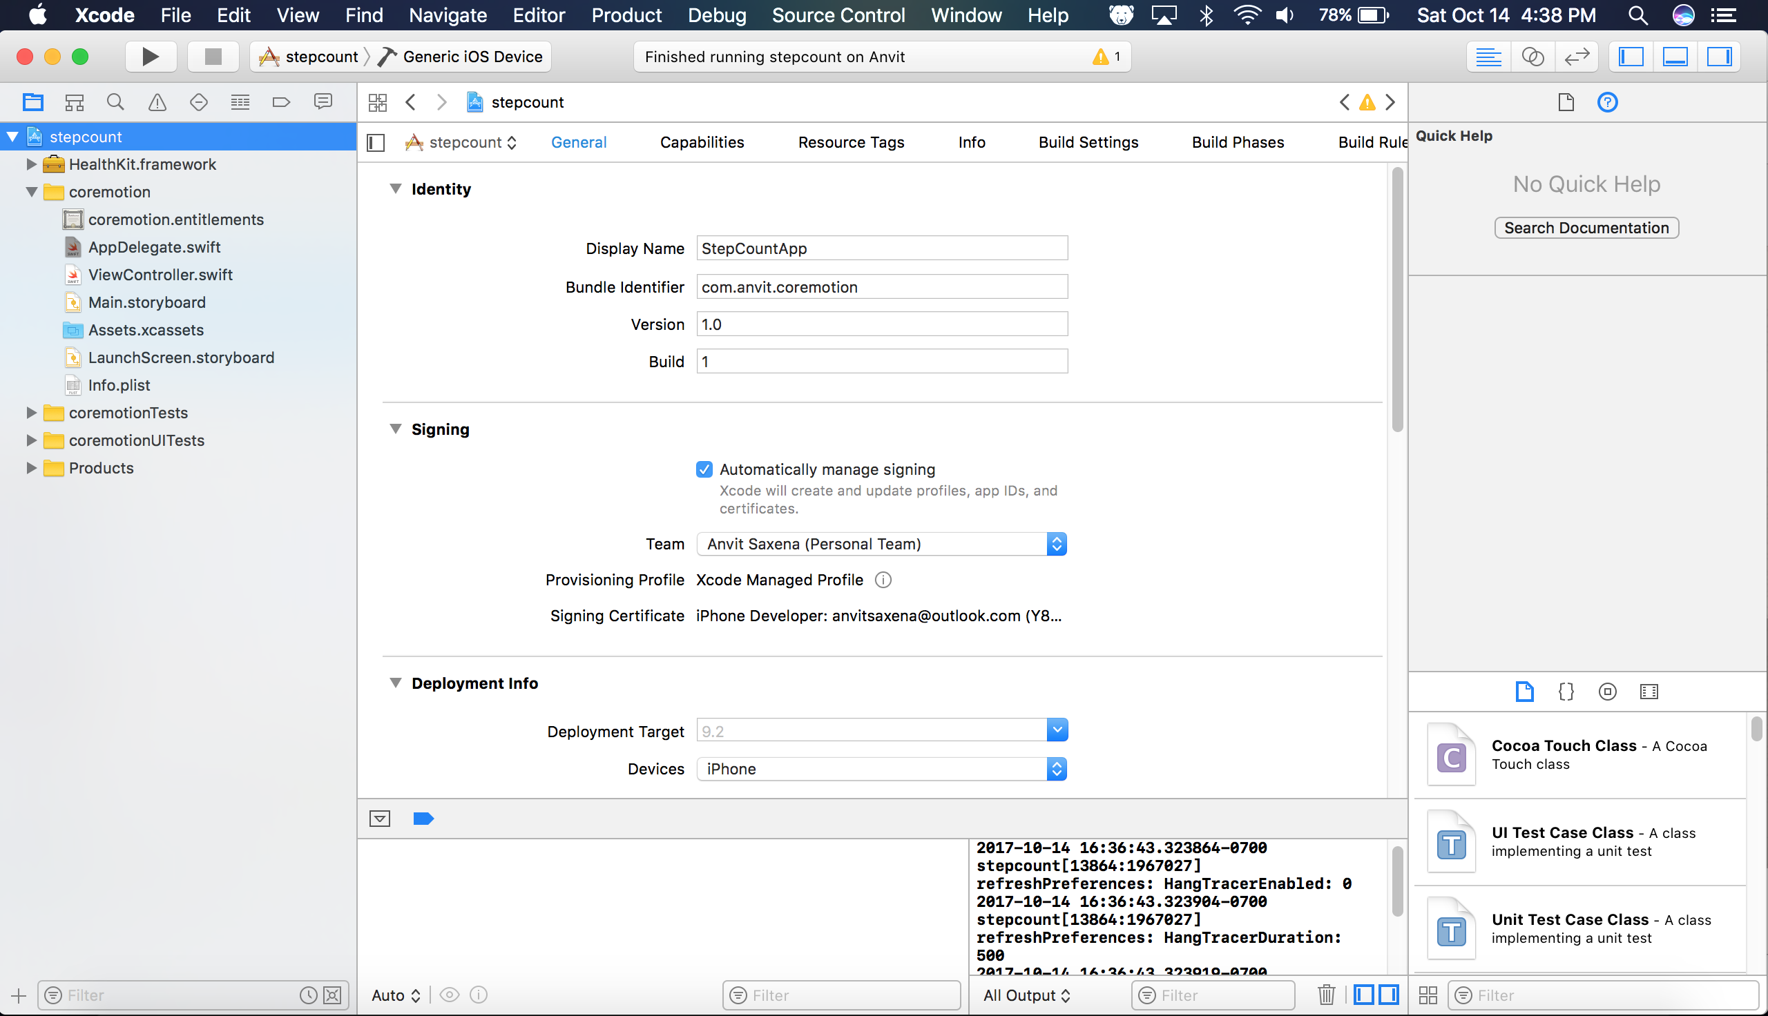

Screenshot 3: Welcome page of the application. User can click start workout to start gathering the user’s movements.

